FINANCE FUND CAPITAL CORPORATION
HEALTHY FOOD FOR OHIO PROGRAM
CORNER STORE FEASIBILITY STUDY - TOLEDO

JUNE - 2018

The purpose of this study was to assess the feasibility of connecting local farmers with customers in corner store operations located in low to mod income areas of Toledo where fresh produce is typically not offered.
By localizing the food economy, we will promote a triple win strategy by aggregating demand for healthy food products, increase community access to healthy foods and increase markets for local producers.
This study addressed the following issues:
- Review other case studies:
  - Definition
  - The Food Trust
  - “Get Healthy Philly Initiative”
  - “Eat Fresh Live Well”
  - “Cooking Matters”

- Assess Farmer capabilities:
  - Select Farmers
  - Product Pricing

- Select viable corner stores as distribution and sales locations:
  - Selection Criteria/Process
  - Data Collection
  - Data Classification
  - Engagement (Interest)

- Identify implementation strategies:
  - Collaboration
  - Roles and Responsibilities
  - Logistics
    - Communication (Phone, email, text?)
    - Payment (Cash/Check/Invoicing/Electronic)
  - Program Budget

- Recommendations to Achieve a Sustainable Long-Term Program – ASAP:

ATTACHMENTS:
- PHILADELPHIA’S HEALTHY CORNER STORE INITIATIVE / Q&A
- MARKETING MATERIALS – TOOLS AND STRATEGIES
- PRODUCT PRICING & SELECTION
- 179 SNAP/WIC LOCATIONS IN BUSINESS IN THE TOLEDO AREA
- BREAKEVEN ANALYSIS & SPREADSHEET

- Review Other Case Studies:

- Definition:
    - Healthy Corner Stores Network www.healthycornerstores.org/faq defines a corner store is typically defined as a small-scale store that sells a limited selection of foods and other products. Other terms that are commonly used to refer to this type of store include a small-scale store, convenience store, neighborhood store, and bodega.
    - The Food Trust http://thefoodtrust.org defines corner stores as having less than 2,000 square feet, four aisles or less and one cash register

- The Food Trust:
    - Alvaro Drake-Cortes, Senior Project Manager for the Healthy Corner Store Initiative (The Food Trust) in Philadelphia, was contacted on 06-11-18. We reviewed their program with a series of Q&A’s (Attachment I) to gain insight on the pros and cons they experienced managing their corner store initiative. Alvaro also put us in touch with Carolyn Huckabay, Marketing Coordinator for the Food Trust who provided us with links to their marketing material on 06-19-18. The insight gained from both individuals was invaluable.

- “Get Healthy Philly Initiative”:
    - Jennifer Aquilante Robinson is the Food Policy Coordinator for the “Get Healthy Philly Initiative.” She works for the Philadelphia Department of Public Health, Division of Chronic Disease Prevention. We also asked her to share her observations about the corner store program in the city of Philadelphia’s perspective, but unfortunately, after several attempts, we were unable to connect.

- “Eat Fresh Live Well”:
    - The program http://www.healthylucascounty.org/initiatives/healthy-eating/corner-stores/ is a healthy corner store initiative that helps convenient stores provide fresh fruits and vegetables to customers throughout Lucas County. Locally we met several times with Tony Maziarz who is project coordinator for Toledo’s “Creating Healthy Communities” initiative for the Toledo-Lucas County Health Department. Amy Adodeely, the Dietitian, was also a part of these discussions.
Toledo-Lucas County Health Department was awarded a 3-year CDC grant that funded a corner store program from 2015-2017, very similar to what this feasibility study is evaluating. Since the grant concluded September 30, 2017, the “Eat Fresh Live Well” program has continued but at a scaled down level. It was also deemed financially unsustainable at the time for two reasons:
  - A local distributor provided produce for the program. Initial volumes were low and inconsistent making it more of a management challenge for them with limited markup opportunities to continue long-term.
  - Lott Industries, a private sector non-profit provided the manpower necessary to deliver produce items. They too could not generate enough cash flow to sustain their involvement. The other issue was they only delivered biweekly which resulted in a high ratio of spoiled produce.

Eliminating the delivery portion of the program also resulted in 28 “Stop & Shop” type gas station-carryout store locations to cease participation in the program. Produce needed to be delivered to them on a regular, weekly basis. The managers were not given an option to leave the store and purchase produce for each of their locations. With a delivery and management system in place, this could be resurrected if MVGA provides this service.

The county’s current list of corner store 17 participants is:

Save Way Market, 1936 Broadway, Toledo, Ohio 43609
Moe’s Market, 4401 Hill Ave., Toledo, Ohio 43615
$1.50 Plus, 1312 Nebraska Ave., Toledo, Ohio 43607
Madison Market, 901 Madison Ave., Toledo, Ohio 43604
Tom’s Carry Out, 2861 Lagrange St., Toledo, Ohio 43608
Gas and Shop, 3100 N. Detroit Ave., Toledo, Ohio 43610
Mike’s Carry Out, 408 Cleveland St., Toledo, Ohio 43611
Market on the Green, 1806 Madison Ave., Toledo, Ohio 43604
Jennifer Snack, 601 Adams St., Toledo, Ohio 43604
Olney Lakeside Market, 1950 N. Stadium Road, Oregon, Ohio 43616
Up Market, 1941 Dorr St., Toledo, Ohio 43607
Takacs Grocery & Meats, 1956 Genesee St., Toledo, Ohio 43605
Andy’s Carry Out, 802 Western Ave., Toledo, Ohio 43609
Citgo Convenience Express, 1708 E. Manhattan Blvd., Toledo, Ohio 43608
Milo’s Food Mart, 4508 Lewis Ave., Toledo, Ohio 43612
E-Z Mart, 1226 E. Broadway St., Toledo, Ohio 43605
Berdan Mini Express, 1001 Berdan Ave., Toledo, Ohio 43612
- “Cooking Matters”:
      - Also involved in Toledo’s Healthy Corner store Initiative is OSU Extension Agent, Suzanne Saggese. She runs the SNAP Education program and schedules “Cooking Matters” classes in the region. Suzanne currently sits on the Health Department’s board that oversees the project. She was a wealth of information.
    - Suzanne’s observations:
      - Some store failures were as a result of store employees not keeping up with quality control issues. The single owner, smaller and independent stores seem to be more successful.
      - All items are currently sold separately. Nothing is prepackaged. A consideration might be to add a choice for the customer that is either pre-packaged or bagged with a select group of produce items that would make up one or two meals. Include a recipe card with pictures of the prepared meal in the bag. The ideal weight and cost of the bag have to be manageable.
      - Seconds or #2’s should be considered for sale along with marketing signage that explains what they are and why they are still equally nutritional. (Often times #2’s are either too big, too small or are slightly deformed.) Many stores are already using seconds but not acknowledging this. If successful, this could be a second-tier pricing structure (Ugly Veggies).
      - Generally, minimal refrigerated space is available limiting the number of greens and some fruit.
      - Bananas, oranges, pineapples even though they are not local items must be offered to complement local produce items.
      - There are currently 19 corner stores active in the program.
      - Kent State University did a pre and post-program simple survey.
      - The Board still has 4-5 racks/shelves and baskets available for use at new locations

Suzanne also stated that the Board continues to guide the initiative and meets bimonthly. I attended the meeting on 07-19-18. They are looking for sponsorship money (E.g., health systems, a nutrition specialist in the area) to support the program. Their next meeting is 08-01-18 a special meeting to further discuss potential startup details.

Other contributors to the Health Departments program offering a historical perspective, insight and additional recommendations were Yvonne Dubielak, Executive Director from Toledo Grows and Beth Deakins, administrator for Toledo’s YMCA - Live Well program.

Beth is interested in using MVGA as a small farmer resource to support produce needs for their 30 child-care programs. She would like to start with 6-8 sites initially. This account could greatly enhance the sustainability requirement of the corner store program.

- Local Attributes/Observations:
    - The leadership team involving the Toledo-Lucas County Health Department, YMCA, and OSU Extention continues to successfully collaborate to achieve its goals. Adding the Maumee Valley Growers is the missing logistics piece that if put in place, could augment the existing corner store program. Each organization provides a unique role in the success of this proposal. More involvement with one or both of the two hospital systems would be helpful and a valued asset. Current and future roles and responsibilities are listed below:
    - Toledo-Lucas County Health Department – Maintain management control of corner store relationships, marketing, and shelving materials. For more information on marketing, tools and strategies see (Attachment II)
    - YMCA - Continue health and wellness education with nutrition experts.
    - OSU Extention – Organize and schedule cooking classes, provide recipe cards.
    - MVGA – Manage the farmers, their produce, aggregation, invoicing and weekly delivery.

The mission and vision of each organization also align nicely with a corner store project.
The community benefits by involving local farmers, nonprofits such as hospitals, food banks and other like-minded agencies and organizations. We believe in shifting community health programs to a more proactive healthy, local food produced opportunities to prevent disease
Eventually transforming food availability to all regions of the Toledo area to reduce the environmental footprint, become a community leader for sustainability for economic, and environmental health is a goal closely shared with each organization.
A healthy food system would provide healthy food access for all, localized food economies.

- Assess Farmer Capabilities:

- Select Farmers
- We crosschecked the capabilities of small farmers to provide produce variety, and volumes throughout the year distributed by the Maumee Valley Growers Association’s (MVGA) food division to connect with owners of urban corner store businesses.

Using combined lists from MVGA, OSU Extension, and the Toledo Farmer’s Market members, we were able to identify 67 potential farms in our area as potential produce producers. We prioritized their interest levels, farming capabilities, food safety practices (GAP) and selected the farms listed below capable of participation in Toledo’s corner store initiative as of 07-09-18.

Eshleman Farms (Jeff)
Riehm’s Farms (Phil)
Schmidlin Greenhouse (Don)
Smith Brothers Farms (Ray)
That One Farmer Guy (Matt)
Whitehouse Specialty Crops (Wade)
Witt Orchards (Heather)

Note that more farmers had the means to participate but were not GAP safety certified. As a result, they had to be unfortunately eliminated as a producer resource.
A few farmers were interested in selling #2’s or so-called “Ugly Veggies.” This would be extremely beneficial to the program’s pricing structure. Much of the savings could be passed on to the consumer. However, this would require a significant time management effort between the farmer and aggregator (MVGA). It would also generate significant pricing inconsistencies which might confuse the buyers. More thought needs to be spent on the pros and cons of using #2’s.

- Product Pricing and Selection

The study determined that there are two types of corner stores; the smaller, typical corner store limited in budget, sales, and space (see definition 1a) and a moderately sized store which exceeds our definition but is located in food desert areas.
    - Smaller Corner Stores: Because of smaller budgets, sales, and space, MVGA will provide a limited, but generous offering of produce items (21) to our most of our corner stores participants. The aim is to keep the program simple and easy to manage. A list of those items and pricing are detailed in Attachment III. After some testing, it was agreed that one size bag would work for the $5 Grab Bag pricing. The determining factor is the length of the corn.
    - Corner Stores: We anticipate between 6-8 medium sized corner store participants. Because they have a greater volume of sales and customer traffic, MVGA will be able to offer their full array of produce items similar to what is offered to their wholesale distributors. Pricing is virtually identical while the packaging is in larger bundles, ½ - 1 Bu. Boxes etc. The full price list will be made available to each medium size corner store.

- Select Viable Corner stores as Distribution and Sales Locations:

- Selection criteria/process
    - Using the color-coded online from the 2015 USDA target zone maps, we were able to identify a total of 526 store locations accepting the SNAP and the WIC programs.
    - Those locations were then cross-referenced to include only corner stores who accept the SNAP and WIC program for which 330 corner stores were identified.
- Phone numbers were verified for accuracy. Many stores had closed over the last three years including gas station locations and several franchises. This vetting process lowered corner store locations further to 233 SNAP/WIC locations in the Toledo area still in business
- To confirm those findings, we conducted a “drive-by” of each location to verify if they were still in business. This also included a preliminary visual assessment. 179 stores (Attachment IV) were still in business and considered our core targets.

- Data Collection
- Our final confirmation of potential store participants required in-person visits. MVGA met with the owner/managers of 108 of the 179 stores to explain the program, evaluate their location internally and gauge their level of interest. Marketing materials were shown with several handouts left behind with additional information. Observations were made on the following store assets:

- Store Location and Food Traffic
- Store Maintenance and Feel (Marketing/Signage)
- Store Space and Inventory
- Refrigeration
- Owner’s Knowledge and attitude
- Pricing/Logistics

- Data Classification
- Each location was classified into three priorities or categories:

LI & LA 1 and 10 miles (highest priority) - 47 locations
- Visited - 37
- Not Visited - 10
Of the 47 locations, 6 were corporate, 5 were out of business, 1 not interested and 1 deemed a safety issue reducing this category down to 34 possible locations. 10 Stop & Go and Stop and Shop locations that were not visited.
LI & LA .5 and 10 miles (second priority) - 100 locations
      - Visited – 64
      - Not Visited - 36
Of the 100 locations, 22 were corporate, 3 were out of business, 0 not interested and 0 a safety issue reducing the category down to 75 possible locations. 14 Stop & Go and Stop and Shop locations that were not visited.
Very near to priorities #1 & #2 (Unclassified locations) - 32 locations
      - Visited - 7
      - Not Visited - 25
Of the 32 locations, 2 were corporate, 2 were out of business, 0 not interested and 0 a safety issue reducing the category down to 28 possible locations. 2 Stop & Go and Stop and Shop locations that were not visited.

- Engagement (Interest)
    - There was a mixed sense of commitment to a belief in the corner store vision among the majority of participants. The greatest apprehension was pricing and consistent weekly deliveries.
    - Corner store operators hold a mostly positive view of the project. Again, many were concerned that local product pricing may discourage limited customer purchases.
    - Many perceived the decision-making process within the supply chain to be unclear and more top-down.
    - Generally, participants felt there is inadequate community engagement to realize the corner store vision.
    - Perceptions were similar between corner store operators and their customers regarding its long-term success. They generally endorsed the program but were skeptical.
    - Participants did express positive benefits through new partnerships and increase access to resources in new revenue.

- Identify Implementation Strategies:
Can this proposal become a sustainable operation for all supply chain participants? Much of this answer depends on the cost of the local farmer’s produce. It must be enough to make it worthwhile for the farmer to participate, yet economical enough for MVGA’s 11% markup to pay for the logistics, have enough room for the store owner’s markup and yet be affordable for the consumer.
On June 11, July 02 and 19, MVGA met with the members of the Toledo-Lucas County Health Department, the YMCA, and OSU Extension to review their current supply chain and strategize on how to best augment the current health department program and raise it to the level of long-term sustainability. We also met with the Y on July 10, 2018, to focus on pricing strategies.

During those meetings, many aspects of the supply chain were examined including product availability, aggregation, fulfillment requirements, pricing, packaging, billing and finally education and promotion. Attention to details includes food safety, bunch sizes, product placement, labels, contracts, communication, program management, sequential planting, quality control, product trends and more.

The next meeting between MVGA, the Health Department, YMCA and OSU Extension is scheduled for August 1, 2018.

As a result of this meeting and other discussions, recommendations to achieve a sustainable long-term program are detailed below:

Farmer
→
→
Food Hub
(Aggregation)
Corner store
(Deliveries)

- Logistics
    - MVGA must be prepared for three modes of communication, phone, email, and text.
    - Payment procedures will be mixed. Some prefer writing checks others accept invoicing.

- Program Budget

By far, the biggest challenge to sustainability is the cost of doing business. This has been a sticking point with many non-profit programs especially starting with farmer pricing, driver, fuel, and supply chain administrative costs. Experience has shown that managing a program like this could easily be half of the total cost.

If the project can be made sustainable, its impact within the neighboring communities may still be difficult to measure, however, the likelihood of having an active and successful program involving proactive health and nutrition issues in NW Ohio most assuredly would open unknown doors for future expansion and benefit.

- Recommendations to Achieve a Sustainable Long-Term Program – ASAP:

Based on these discussions involving participants within the food supply chain, a “go-forward” recommendation was collectively made by MVGA , Toledo-Lucas County Board of Health, YMCA, and OSU Extension pending the following agreed-upon contingencies:
- MVGA farmer pricing and inventory offerings are accepted. (Gathering this information now)
- Implement a one-day per week delivery schedule beginning in August with intentions of reaching volume and variety levels capable of sustaining the program long-term.
- Re-assess the program on November 15, 2018, for sustainability goals and accomplishments (See Attachment V)

If the program is deemed unsustainable, it will be terminated with a 2-week notice to all participants.

If the program is tracking at a sustainable rate, it will continue on a 12-month basis with quarterly reviews.

The ideal months of local produce available vary but are generally considered a 7-8 month cycle here in Ohio. During the “off months,” select items are available (apples, potatoes, other root crops, etc.) through farmer refrigeration and storage. As a result, the corner store produce selection will have to be supplemented through other sources (Ciolino’s, Cosco, etc.) to maintain program consistency throughout the annual cycle.

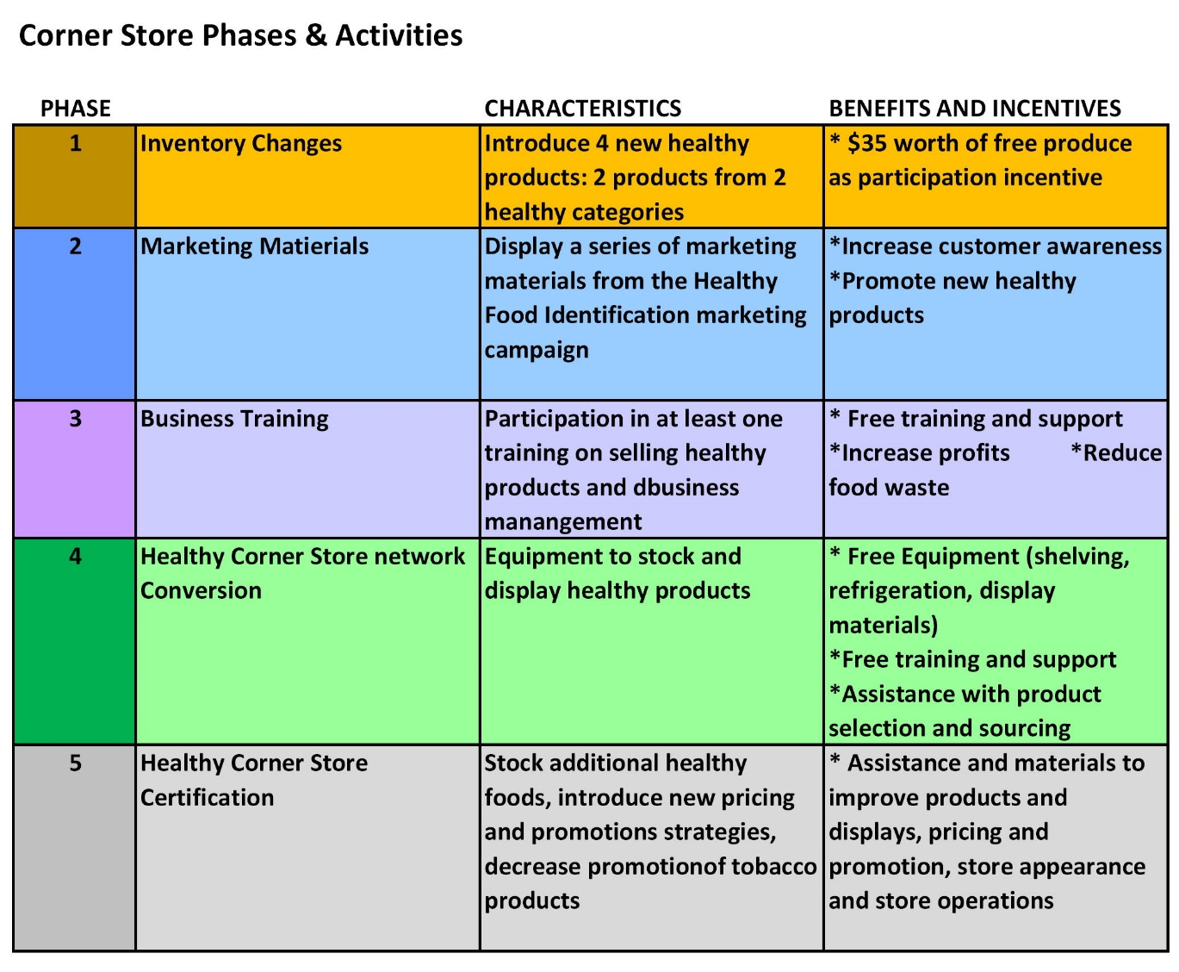
ATTACHMENT I

The following Q&A was discussed on 06-11-18 between Alvaro Drake-Cortes Senior
Project Manager for Philadelphia’s Healthy Corner Store Initiative and
Maumee Valley Growers Executive Director Joe Perlaky

- What does Philadelphia’s Healthy Corner Store Initiative provide?
We initiate contact with each corner store location and evaluate their capabilities to provide a sustainable, farm fresh food program. We provide technical services such as marketing and food placement strategies. We also provide a “point of purchase” marketing materials free of charge to each participating business. All deliveries of food items are provided and managed by farmers or third-party vendors.
- Regarding the success of each store location, did it matter if you talked with the owner or the manager?
As long as the person you meet is empowered to make the decisions and commitment to the program the position of Owner or Manager are both acceptable.
- How did you initially contact the store owners? Mailer? In person? Phone? Email? Text?
We discovered early on that postcards, emails and phone call was ineffective. Making a cold call in-person offered the best opportunity to get to the decision maker. This is not unusual in this industry. Rarely are appointments made since calls are screen and mail is discarded.
- Did you eliminate any locations as result of:

  - Safety:
We conducted onsite assessments prior to visits. Some locations were considered higher safety risks and were eliminated in the beginning.
  - Gas station classification:
Fuel stations often play an important role in providing neighborhoods with food items. They often offer good traffic counts, located on corners with easy access and display greater safety attributes.
  - Franchise store such as Rite Aid or Walgreens?
Generally, franchises are not good choices as corner store locations primarily because corporate ownership and management are not on site. There are some exceptions. A personal visit can make that determination.
- How is billing customarily handled?
Mostly cash, followed by writing checks upon delivery by the owner or manager on site.
- How many times per week are your deliveries?
Produce has a limited shelf life. Balancing delivery costs with produce volume, variety and spoilage is a fine line. Start with one delivery per week and if volume supports an additional day, add as needed.
- What is the average volume or dollars per delivery?

Unknown.

- Pricing:

  - Did you use seconds?

No, #1’s. However, #2’s or “Ugly Veggies” should be explored to reduce customer costs.

  - Do you provide pre-packaging fruit or vegetable trays?

The supplier does occasionally.

  - Donations?

The supplier does not use donated produce.

- Refrigerator: Do you recommend a countertop or a floor model?
It depends on space and electric availability. We recommend a location as close to the cash register as possible. Most produce other than greens, and seasonal berries do not require refrigeration making the need for refrigeration less necessary. Often times there is available space in “open coolers” at the store.

- What were some of the big mistakes you made early on?

Expecting postcards and phone calls to “open doors.” Personal visits were the most effective strategy.

- What were some of the surprises?
The importance of marketing and leaving behind materials during each initial visit.
- If you have to do it all again what would you do differently?
Point out during the initial visit this program is to supplement a corner store inventory not replace it. This could add “new found” dollars to the sales totals especially since the program can be advertised as a unique service and beneficial partnership in their neighborhood.
- Can the program be sustainable?
The store owner and manager’s commitment and support are the most important factors to a long-term sustainability achievement.

ATTACHMENT II
MARKETING MATERIALS – TOOLS AND STRATEGIES

The use of marketing materials as developed through the Toledo-Lucas County program “Eat Fresh Live Well” should be continued and further developed as needed. As a result of this 3-year program, the Toledo area is conditioned to the importance of internal and external Corner store promotional needs.

Adding MVGA to the supply chain along with existing program relationships should enhance attention to details of produce varieties, quality control, pricing, communication, sequential planting, merchandising, trends, and more. Although scaled down, the fact the Health Department continued the program beyond the grant years is a big advantage in convincing many stores to recommit especially in light of offering a delivery service and managed inventory.

Working with the wholesale buyer to promote the local farm brand brings advantages of direct marketing. Wholesale buyers and their customers are motivated to keep a locally branded product on the shelf—it differentiates them from the mass-market. This was not the case originally working with a distributor and third-party fulfillment. We anticipate that customers will learn who we are and develop brand loyalty. Without a farm brand, the product is replaceable for another of like kind. Telling a compelling story about participating local farmers is one factor critical to long-term program sustainability.

Provide standardized marketing model and strategies.
- “Grab Bags”
- Colorful guides on nutrition
- Colorful shelf runners
- Other promotional signage
- Containers (plastic) or baskets
- Shelving
- MVGA professional appearance such as a wrapped refrigerated truck and consistent delivery service.
- Recipe Cards: Detailing healthy, low-cost meals.

- Continued collaborative support is needed to leverage corner store sustainability with the focus on investment for health, wealth and nutritional understanding. The Toledo-Lucas County Health Department, YMCA and OSU Extension are already working together promoting this initiative. ProMedica, Mercy HealthCare Partners, and others need to be added to the program.
- Educational sessions on topics related to health, wealth, nutritional understanding and food preparation are important components of the corner store initiative. Suzanne Saggese’s continued scheduling of cooking classes for SNAP and WIC users are very important.
- Often overlooked is the value of promoting healthy corner stores beyond the context of basic public health to include benefits that could improve community safety, community revitalization, environmental sustainability, economic development, community planning and general food retail. Working collectively on a common goal stimulates pride and ownership of each neighborhood reducing crime and other potential risk factors.
- “Buying Local” develops an interconnected system of local businesses that support each other. Purchasing refrigeration and other equipment from local companies, hiring healthcare experts within the neighborhood who provide training and assistance, using local designers for our marketing campaign, and sourcing food from a community garden or local farmers.
- “Grab Bags” - After much discussion, two sizes will be tested. One $5 bag with a handful of vegetables will be provided to satisfy WIC customers while a larger $10 bag with a larger assortment of vegetables will also be created. Each bag will have a recipe card with cooking instructions and a picture of the finished meal. A third “Grab Bag” will only have fruit probably in the $10 price range.
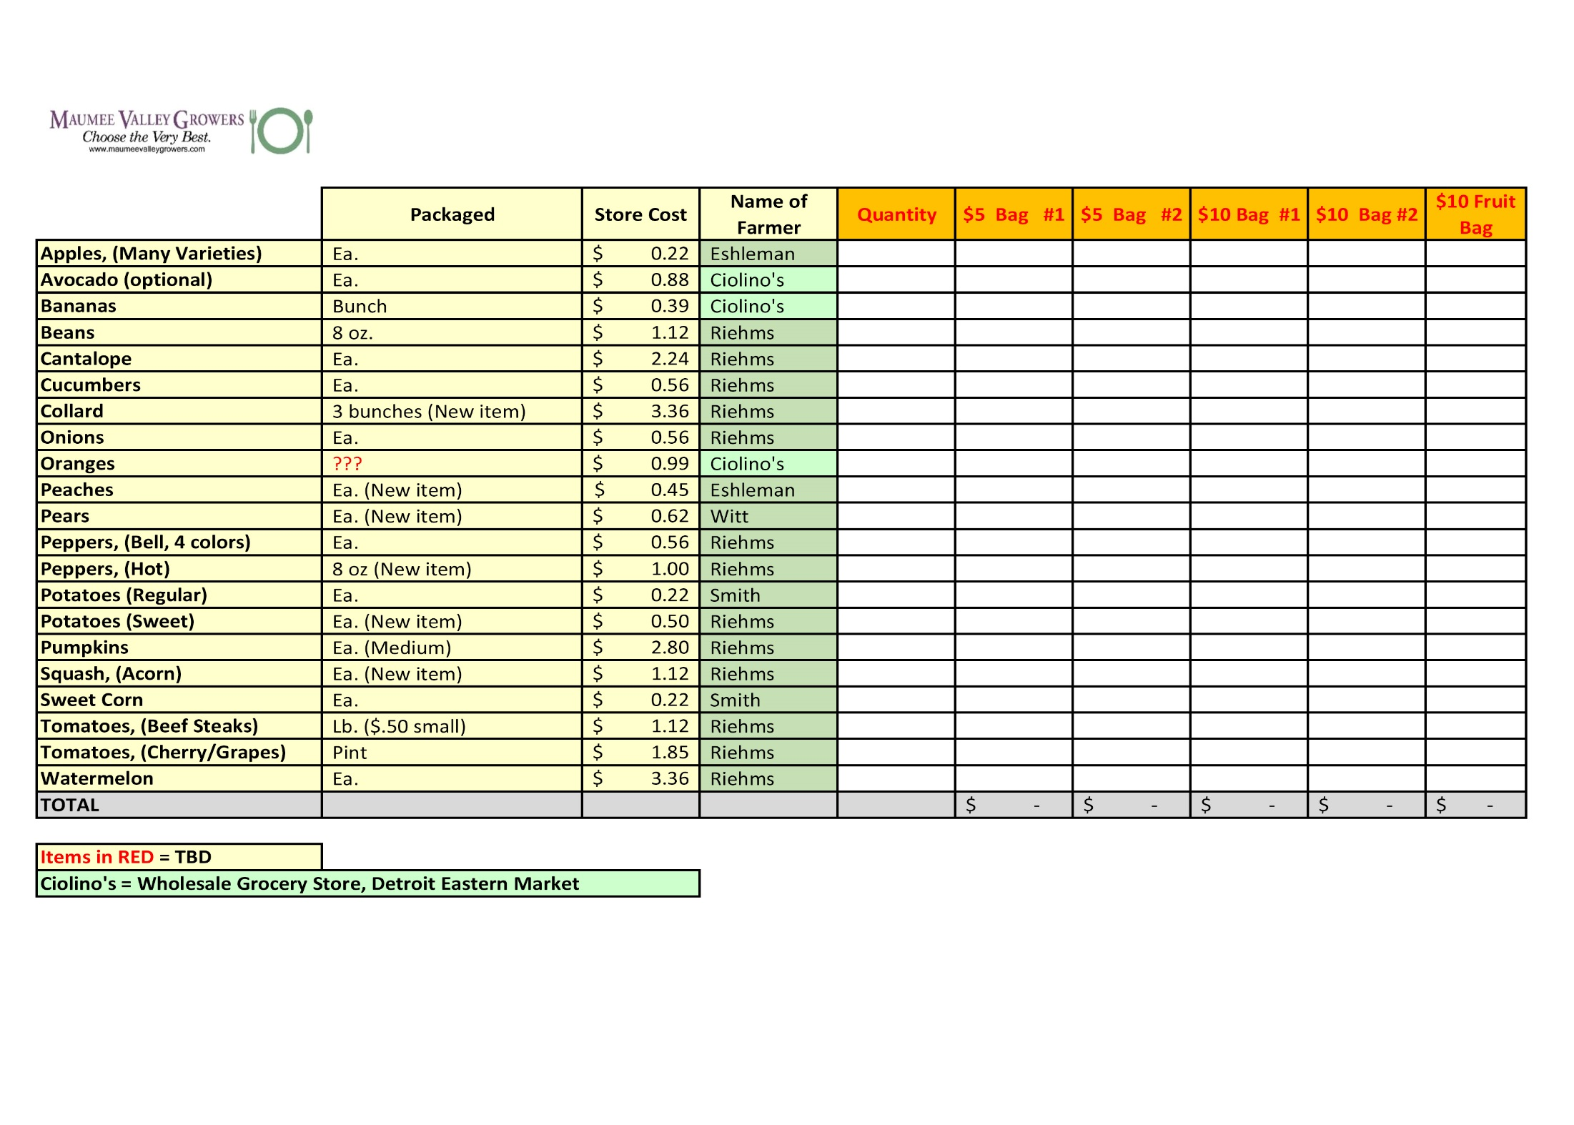
ATTACHMENT III
PRODUCT PRICING & SELECTION

ATTACHMENT IV
179 SNAP/WIC LOCATIONS IN THE TOLEDO AREA STILL IN BUSINESS

# | Business Ranking | Personal Visit | Store Name | Address | City | State | Zip | Contact | Phone
1 | 1 |  | 7-ELEVEN 18215-B | 3151 Lagrange St | Toledo | OH | 43608 |  | 419-255-8141
2 | 1 |  | ASIAN GROCERY | 1801 N McCord Rd Ste C | Toledo | OH | 43615 |  | 419-866-2102
3 | 1 |  | Carbon Ps Mart 6014 | 1540 Front St | Toledo | OH | 43605 |  | 419-698-2723
4 | 1 |  | CIRCLE K 5322 | 1235 N Holland Sylvania Rd | Toledo | OH | 43615 |  | 419-531-9840
5 | 1 |  | Circle K 5638 | 2969 Tremainsville Rd | Toledo | OH | 43613 |  | 419-471-9536
6 | 1 |  | Circle K 5651 | 6775 Dorr St | Toledo | OH | 43615 |  | 419-865-9134
7 | 1 |  | Combo 4 | 5831 Dorr St | Toledo | OH | 43615 |  | 419-214-0177
8 | 1 |  | CONSAUL FOOD MARKET | 2625 Consaul St | Toledo | OH | 43605 |  | 419-693-3287
9 | 1 |  | Crosstown Carryout | 855 S Holland Sylvania Rd | Toledo | OH | 43615 |  | 419-865-4500
10 | 1 |  | DAIRY MART 5480 | 3380 Lagrange St | Toledo | OH | 43608 |  | 419-241-8691
11 | 1 |  | DEANO'S MINI MART TOO | 11 N McCord Rd | Toledo | OH | 43615 |  | 419-867-0444
12 | 1 |  | DETROIT STOP GROCERY | 2516 N Detroit Ave | Toledo | OH | 43610 |  | 419-242-5474
13 | 1 |  | Food For Less | 350 W Central Ave | Toledo | OH | 43610 |  | 419-254-1200
14 | 1 |  | Gas and Shop | 3100 N Detroit Ave | Toledo | OH | 43610 |  | 419-241-4750
15 | 1 |  | Gas Express South | 324 S Detroit Ave | Toledo | OH | 43609 |  | 419-724-9520
16 | 1 |  | Holland Sylvania Mini Mart | 1034 N Holland Sylvania Rd | Toledo | OH | 43615 |  | 419-725-9210
17 | 1 |  | ISLAND VARIETY | 722 Dearborn Ave | Toledo | OH | 43605 |  | 419-691-9277
18 | 1 |  | LINCOLN MARKET | 2743 N Detroit Ave | Toledo | OH | 43610 |  | 419-241-7707
19 | 1 |  | Midtown Food Mart #3 | 6204 Hill Ave | Toledo | OH | 43615 |  | 419-913-3340
20 | 1 |  | Midtown Foodmart | 2560 Dorr St. | Toledo | OH | 43607 |  | 419-536-3941
21 | 1 |  | MIKE'S PLACE | 3170 Cherry St | Toledo | OH | 43608 |  | 419-244-4089
22 | 1 |  | MILO'S FOOD MARKET INC | 4508 Lewis Ave | Toledo | OH | 43612 |  | 419-476-4327
23 | 1 |  | MOE'S MARKET | 4401 Hill Ave | Toledo | OH | 43615 |  | 419-535-7225
24 | 1 |  | One Stop Carryout | 1602 Lagrange | Toledo | OH | 43608 |  | 419-243-7060
25 | 1 |  | Reynolds Quick Stop | 13 S Reynolds Rd | Toledo | OH | 43615 |  | 419-535-6074
26 | 1 |  | Rite Aid 2310 | 210 Main St | Toledo | OH | 43605 |  | 419-691-5851
27 | 1 |  | Rite Aid 2318 | 5224 Dorr St | Toledo | OH | 43615 |  | 419-531-2115
28 | 1 |  | Rite Aid 6680 | 114 S Byrne Rd | Toledo | OH | 43615 |  | 419-535-0069
29 | 1 |  | SAVE A LOT | 1703 Airport Hwy | Toledo | OH | 43609 |  | 419-382-4545
30 | 1 |  | SAVE-A-Lot 9 | 5229 Dorr St | Toledo | OH | 43615 |  | 419-774-7990
31 | 1 |  | STOP & GO | 2154 South Ave | Toledo | OH | 43609 |  | 419-385-5566
32 | 1 |  | STOP & GO | 4252 Lewis Ave | Toledo | OH | 43612 |  | 419-724-4204
33 | 1 |  | STOP & GO | 653 Main St | Toledo | OH | 43605 |  | 419-693-3969
34 | 1 |  | STOP & GO #38 | 3503 Hill Ave | Toledo | OH | 43607 |  | 419-531-2419
35 | 1 |  | STOP & GO 11 | 505 Eleanor Ave | Toledo | OH | 43612 |  | 419-478-3391
36 | 1 |  | STOP & GO 12 | 5013 Bennett Rd | Toledo | OH | 43612 |  | 419-476-2168
37 | 1 |  | STOP & GO 24 | 4721 Lewis Ave | Toledo | OH | 43612 |  | 419-478-5412
38 | 1 |  | STOP & GO# 3 | 1223 Byrne Rd | Toledo | OH | 43607 |  | 419-531-8225
39 | 1 |  | Stop And Shop 127 | 5409 Dorr St | Toledo | OH | 43615 |  | 419-724-5885
40 | 1 |  | Stop And Shop 135 | 541 N Reynolds Rd | Toledo | OH | 43615 |  | CLOSED?
41 | 1 |  | TAKACS GROCERY & MEAT MKT | 1956 Genesee St | Toledo | OH | 43605 |  | 419-693-9233
42 | 1 |  | TEE ORIENTAL FOOD & GIFTS | 1101 N McCord Rd | Toledo | OH | 43615 |  | 419-866-6484
43 | 1 |  | THE CORNERSTORE | 250 S Fearing Blvd | Toledo | OH | 43609 |  | 419-382-7000
44 | 1 |  | Tj Mart | 6636 Bancroft St | Toledo | OH | 43615 |  | 419-724-1515
45 | 1 |  | Toledo 76 Inc 6012 | 1896 Front St | Toledo | OH | 43605 |  | 419-691-1605
46 | 1 |  | Vermag's Glass City Meats Corner Store | 702 W Sylvania Ave | Toledo | OH | 43612 |  | 419-214-0677
47 | 1 |  | Walgreens 05324 | 1330 N Reynolds Rd | Toledo | OH | 43615 |  | 419-536-3840
1 | 2 |  | 7-ELEVEN 17534B | 2601 W Bancroft St | Toledo | OH | 43607 |  | 419-531-4384
2 | 2 |  | 7-ELEVEN 18142A | 1321 Navarre Ave | Toledo | OH | 43605 |  | 419-691-6145
3 | 2 |  | 7-Eleven 19776J | 537 Woodville Rd | Toledo | OH | 43605 |  | 419-691-2759
4 | 2 |  | 7-Eleven Inc F 19774E | 3749 Upton Ave | Toledo | OH | 43613 |  | 419-472-4417
5 | 2 |  | Airport Stop I | 3326 Airport Hwy | Toledo | OH | 43609 |  | 419-382-7711
6 | 2 |  | AJ's Carry Out | 868 E Broadway St | Toledo | OH | 43605 |  | 419-691-9600
7 | 2 |  | ALDI 64 | 3015 Glendale Ave | Toledo | OH | 43614 |  | 855-955-2534
8 | 2 |  | AMERICAN PETROLEUM | 5001 Douglas Rd | Toledo | OH | 43613 |  | 419-472-2529
9 | 2 |  | Andy's Carry Out | 802 Western Ave | Toledo | OH | 43609 |  | 419-243-3551
10 | 2 |  | AUBURN MINI MART | 2367 Auburn Ave | Toledo | OH | 43606 |  | 419-472-9703
11 | 2 |  | Barneys Convenience Mart Inc 24 | 3126 Secor Rd | Toledo | OH | 43606 |  | 419-536-8456
12 | 2 |  | Barneys Convenience Mart Inc 35 | 3532 Stickney Ave | Toledo | OH | 43608 |  | 419-729-2506
13 | 2 |  | BASSETT'S WESTGATE HEALTH FOODS | 3344 Secor Rd | Toledo | OH | 43606 |  | 419-531-0034
14 | 2 |  | BEER DOCK | 932 N Huron St | Toledo | OH | 43604 |  | 419-242-1418
15 | 2 |  | Bekos Market 2, Llc | 868 Oakwood Ave | Toledo | OH | 43607 |  | 419-241-1315
16 | 2 |  | Bush Quick Stop | 702 Bush St | Toledo | OH | 43604 |  | 419-244-7410
17 | 2 |  | CAPTAIN'S CARRYOUT | 5928 315th St | Toledo | OH | 43611 |  | 419-726-2077
18 | 2 |  | Circle K | 305 Clayton St | Toledo | OH | 43604 |  | 419-241-2379
19 | 2 |  | Circle K 5648 | 1444 W Alexis Rd | Toledo | OH | 43612 |  | 330-630-6300
20 | 2 |  | Deminent | 1004 N. Summit | Toledo | OH | 43604 |  | 419-255-7296
21 | 2 |  | Downtown Variety | 601 Adams St | Toledo | OH | 43604 |  | 419-243-1880
22 | 2 |  | Eastborn Mini Mart No | 1110 E Broadway St | Toledo | OH | 43605 |  | 419-691-8440
23 | 2 |  | Express Food Mart #1 | 1419 South Ave | Toledo | OH | 43609 |  | 419-385-3921
24 | 2 |  | E-Z Mart | 1226 E Broadway St | Toledo | OH | 43605 |  | 419-693-0802
25 | 2 |  | Fassett Street Drop In | 324 Fassett St | Toledo | OH | 43605 |  | 419-693-9636
26 | 2 |  | Gas And Express Mart | 1049 Western Ave | Toledo | OH | 43609 |  | 419-725-9086
27 | 2 |  | Gas Express | 1410 Starr Ave | Toledo | OH | 43605 |  | 419-686-6855
28 | 2 |  | Gas Express 1 | 3070 Airport Hwy | Toledo | OH | 43609 |  | 419-382-7113
29 | 2 |  | Gas-N-Go | 1530 Cherry St | Toledo | OH | 43608 |  | 419-243-7290
30 | 2 |  | GORDON FOOD SERVICE MP42 | 609 W Alexis Rd | Toledo | OH | 43612 |  | 419-478-5444
31 | 2 |  | Health Foods By Claudia | 3904 Secor Rd | Toledo | OH | 43623 |  | 419-474-2400
32 | 2 |  | Huron Market | 528 Magnolia St | Toledo | OH | 43604 |  | 419-241-4922
33 | 2 |  | Jonna Brothers Pizza | 626 Chestnut St | Toledo | OH | 43604 |  | 419-255-4235
34 | 2 |  | L &W Market | 602 Western Ave | Toledo | OH | 43609 |  | 419-244-8432
35 | 2 |  | LA MEXICANA | 764 Oak St | Toledo | OH | 43605 |  | 419-691-6613
36 | 2 |  | LA PERLA | 2742 Hill Ave | Toledo | OH | 43607 |  | 419-534-2074
37 | 2 |  | Lee Williams Meats Inc. | 3002 131st St | Toledo | OH | 43611 |  | 419-729-3893
38 | 2 |  | Lee Williams Meats Inc. | 3047 Glendale Ave. | Toledo | OH | 43614 |  | 419-382-8824
39 | 2 |  | Lees Oriental Market | 2527 W Laskey Rd | Toledo | OH | 43613 |  | 419-475-9742
40 | 2 |  | Market On The Green | 1806 Madison | Toledo | OH | 43604 |  | 419-255-6765
41 | 2 |  | Max Mart | 310 W Alexis Rd | Toledo | OH | 43612 |  | 419-478-2830
42 | 2 |  | MILT'S CARRY OUT | 962 Pinewood Ave | Toledo | OH | 43607 |  | 419-244-3145
43 | 2 |  | Monnette's Glendale Inc | 4760 Glendale Ave | Toledo | OH | 43614 |  | 419-382-6372
44 | 2 |  | Monnettes Market | 2003 N Reynolds Rd | Toledo | OH | 43615 |  | 419-535-6309
45 | 2 |  | Pete's Market | 3449 Stickney Ave | Toledo | OH | 43608 |  | 419-726-0451
46 | 2 |  | RAINBOW MARKET | 969 Rogers St | Toledo | OH | 43605 |  | 419-698-3944
47 | 2 |  | Rite Aid 1092 | 2450 S Reynolds Rd | Toledo | OH | 43614 |  | 419-865-3130
48 | 2 |  | Rite Aid 1217 | 5765 Secor Rd | Toledo | OH | 43623 |  | 419-473-2451
49 | 2 |  | Rite Aid 2314 | 1605 Broadway St | Toledo | OH | 43609 |  | 419-244-5781
50 | 2 |  | Rite Aid 2316 | 3325 W Central Ave | Toledo | OH | 43606 |  | 419-531-1172
51 | 2 |  | Rite Aid 2317 | 3013 Monroe St | Toledo | OH | 43606 |  | 419-243-9803
52 | 2 |  | Rite Aid 2321 | 2430 Glendale Ave | Toledo | OH | 43614 |  | 419-381-6981
53 | 2 |  | Rite Aid 2346 | 810 E Manhattan Blvd | Toledo | OH | 43608 |  | 419-729-2907
54 | 2 |  | Rite Aid 2637 | 1525 Cherry St | Toledo | OH | 43608 |  | 419-255-9524
55 | 2 |  | Rite Aid 6683 | 3911 Secor Rd | Toledo | OH | 43623 |  | 419-472-8027
56 | 2 |  | Rocket Fuel | 3023 Dorr St | Toledo | OH | 43607 |  | 419-531-3300
57 | 2 |  | San Marco's Super Mercado | 235 Broadway St | Toledo | OH | 43604 |  | 419-244-2373
58 | 2 |  | SAVE-A-LOT | 657 E Manhattan Blvd | Toledo | OH | 43608 |  | 419-729-1238
59 | 2 |  | SAVE-A-LOT | 702 Woodville Rd | Toledo | OH | 43605 |  | 419-691-0332
60 | 2 |  | SAVE-A-Lot 45019 | 2626 W Laskey Rd | Toledo | OH | 43613 |  | 419-472-0982
61 | 2 |  | SAVE-A-LOT 46 | 3030 Monroe St | Toledo | OH | 43606 |  | 419-243-3180
62 | 2 |  | SAVE-WAY RED & WHITE | 1936 Broadway St | Toledo | OH | 43609 |  | 419-244-1641
63 | 2 |  | Seagate Farmers' Market | 526 High St | Toledo | OH | 43609 |  | 419-244-6996
64 | 2 |  | Seaman Stop | 2344 Seaman St. | Toledo | OH | 43605 |  | 419-214-1148
65 | 2 |  | SEAWAY MARKET PLACE | 1707 Cherry St | Toledo | OH | 43608 | John | 419-243-1000
66 | 2 |  | SECOR CARRY OUT | 3241 Dorr St | Toledo | OH | 43607 |  | 419-536-3968
67 | 2 |  | Six-12 Mini Mart | 3431 Elm St. | Toledo | OH | 43608 |  | 419-242-4237
68 | 2 |  | Speedway 1070 | 1708 Tremainsville Rd | Toledo | OH | 43613 |  | 419-476-9393
69 | 2 |  | Speedway 1264 | 2510 S Reynolds Rd | Toledo | OH | 43614 |  | 419-866-9876
70 | 2 |  | Speedway 3602 3602 | 5160 Dorr St | Toledo | OH | 43615 |  | 419-535-0861
71 | 2 |  | Speedway 3613 3613 | 5010 Secor Rd | Toledo | OH | 43623 |  | 419-473-0683
72 | 2 |  | Speedway 5264 5264 | 2172 Arlington Ave | Toledo | OH | 43609 |  | 419-381-0602
73 | 2 |  | Speedway 8610 | 2502 W Alexis Rd | Toledo | OH | 43613 |  | 419-472-9975
74 | 2 |  | Speedway 9688 9688 | 1525 W Alexis Rd | Toledo | OH | 43612 |  | 419-478-3313
75 | 2 |  | STANLEY'S MARKET | 3302 Stickney Ave | Toledo | OH | 43608 | Mr. Goscin | 419-726-4347
76 | 2 |  | STOP & GO #1 | 434 E Broadway St | Toledo | OH | 43605 |  | 419-698-3510
77 | 2 |  | STOP & GO #32 | 1401 South Ave | Toledo | OH | 43609 |  | 419-385-4110
78 | 2 |  | STOP & GO #4 | 1806 Arlington Ave | Toledo | OH | 43609 |  | 419-382-9154
79 | 2 |  | STOP & GO #7 | 1901 Broadway St | Toledo | OH | 43609 |  | 419-243-0752
80 | 2 |  | STOP & GO 20 | 740 South Ave | Toledo | OH | 43609 |  | 419-724-5500
81 | 2 |  | STOP & GO 28 | 2101 W Alexis Rd | Toledo | OH | 43613 |  | 419-870-0562
82 | 2 |  | STOP & GO 29 | 551 E Broadway St | Toledo | OH | 43605 |  | 419-697-0048
83 | 2 |  | STOP & GO 4 | 3504 Lagrange St | Toledo | OH | 43608 |  | 419-474-9131
84 | 2 |  | STOP & GO 4 | 5830 Douglas Rd | Toledo | OH | 43613 |  | 419-475-2871
85 | 2 |  | STOP & GO 7 | 1646 W Alexis Rd | Toledo | OH | 43612 |  | 419-470-1330
86 | 2 |  | STOP & GO12 | 2007 W Sylvania Ave | Toledo | OH | 43613 |  | 419-472-6969
87 | 2 |  | Stop And Shop 116 | 1719 Lagrange St | Toledo | OH | 43608 |  | 419-720-6678
88 | 2 |  | Stop And Shop 128 | 801 S Byrne Rd | Toledo | OH | 43609 |  | 419-475-7735
89 | 2 |  | Stop And Shop 138 | 1407 E Manhattan Blvd | Toledo | OH | 43608 |  | 419-726-1958
90 | 2 |  | Stop N Shop | 5086 Douglas Rd | Toledo | OH | 43613 |  | CLOSED?
91 | 2 |  | Sunoco Sunrise 6016 | 5432 N Summit St | Toledo | OH | 43611 |  | 419-729-4144
92 | 2 |  | Sunoco Sunrise 6022 | 1625 Miami St | Toledo | OH | 43605 |  | 419-661-8376
93 | 2 |  | T & G's Carryout | 2267 Auburn Ave | Toledo | OH | 43606 |  | 419-474-2457
94 | 2 |  | The City Grill & Market | 421 N Huron St | Toledo | OH | 43604 |  | 419-243-2489
95 | 2 |  | The Fresh Market 095 | 3315 W Central Ave | Toledo | OH | 43606 |  | 419-531-5218
96 | 2 |  | Toledo Market | 3410 Dorr St | Toledo | OH | 43607 |  | 419-539-4262
97 | 2 |  | Tom's Carryout | 2861 Lagrange St | Toledo | OH | 43608 |  | 419-241-4063
98 | 2 |  | UNIVERSAL MINI MART | 1111 Starr Ave | Toledo | OH | 43605 |  | 419-690-8276
99 | 2 |  | WALGREENS 5319 | 925 Woodville Rd | Toledo | OH | 43605 |  | 419-693-4086
100 | 2 |  | Walgreens 05323 | 1910 S Reynolds Rd | Toledo | OH | 43614 |  | 419-867-3529
1 | 3 |  | ALI'S MEAT MARKET | 3240 W Sylvania Ave | Toledo | OH | 43613 |  | 419-471-9460
2 | 3 |  | American Food Ctr. | 15 W. Bancroft St. | Toledo | OH | 43620 |  | 419-242-1102
3 | 3 |  | BROADWAY FOOD CTR | 1503 Broadway St | Toledo | OH | 43609 | Kenny Shikawana | 419-243-7714
4 | 3 |  | Buckeye Carryout | 740 Buckeye St | Toledo | OH | 43611 |  | 419-726-9506
5 | 3 |  | CVS Pharmacy 10246 | 4121 Monroe | Toledo | OH | 43606 |  | 419-475-4148
6 | 3 |  | Devyn's Market | 1401 N Detroit Ave | Toledo | OH | 43607 |  | 419-244-1842
7 | 3 |  | Dollar & More | 525 Galena St | Toledo | OH | 43611 |  | 419-729-0893
8 | 3 |  | DOLLAR DOLLAR PLUS | 1341 Dorr St | Toledo | OH | 43607 |  | 419-243-6267
9 | 3 |  | DOLLAR FIFTY PLUS | 1312 Nebraska Ave | Toledo | OH | 43607 |  | 419-243-6728
10 | 3 |  | East Side Mini Mart | 615 Oak St | Toledo | OH | 43605 |  | 419-693-2550
11 | 3 |  | ERIE FOOD MARKET | 727 Galena St | Toledo | OH | 43611 |  | 419-726-7650
12 | 3 |  | Family Food Center | 1212 N Detroit Ave | Toledo | OH | 43607 |  | 419-244-4614
13 | 3 |  | Gas Express Bancroft | 350 W Bancroft St | Toledo | OH | 43620 |  | 419-255-1024
14 | 3 |  | Gateway Express 2 | 3819 Haverhill Dr | Toledo | OH | 43612 |  | 419-478-6575
15 | 3 |  | GM Food Mart | 526 N Detroit Ave | Toledo | OH | 43607 |  | 419-244-3660
16 | 3 |  | Gold Star Market | 2123 Lagrange | Toledo | OH | 43608 |  | 419-244-1561
17 | 3 |  | Grab N Gro | 2445 W Alexis Rd | Toledo | OH | 43613 |  | 419-472-1818
18 | 3 |  | LA PALOMA | 1244 Broadway St | Toledo | OH | 43609 |  | 419-243-6232
19 | 3 |  | Lailai Asian Mart | 3205 W Central Ave | Toledo | OH | 43606 |  | 419-725-3563
20 | 3 |  | Milt's Carryout | 1501 Buckingham St | Toledo | OH | 43607 |  | 419-244-3145
21 | 3 |  | Muna Market | 5464 Monroe St | Toledo | OH | 43623 |  | 419-214-0386
22 | 3 |  | Red and White | 1902 N Detroit Ave | Toledo | OH | 43606 |  | 419-244-8741
23 | 3 |  | Rite Aid 2309 | 1012 W Sylvania Ave | Toledo | OH | 43612 |  | 419-478-8177
24 | 3 |  | STOP & GO 18 | 1027 N Reynolds Rd | Toledo | OH | 43615 |  | 419-535-7974
25 | 3 |  | Stop N Shop 40 | 4933 Secor Rd | Toledo | OH | 43623 |  | 419-724-5760
26 | 3 |  | Stop-N-Shop | 5314 W Bancroft St | Toledo | OH | 43615 |  | CLOSED?
27 | 3 |  | Toledo International Market | 2636 W Central Ave | Toledo | OH | 43606 |  | 419-214-0160
28 | 3 |  | Village Carry Out | 1407 Bernath Pkwy | Toledo | OH | 43615 |  | 419-861-9070
29 | 3 |  | VIP Carryout | 241 W. Bancroft | Toledo | OH | 43620 |  | 419-243-4538
30 | 3 |  | WALGREENS 06168 | 4580 Monroe St | Toledo | OH | 43613 |  | 419-474-3915
31 | 3 |  | Wixey Bakery 1 | 2017 Glendale Ave | Toledo | OH | 43614 |  | 419-382-6684
32 | 3 |  | Your Community Market | 1501 Nebraska Ave | Toledo | OH | 43607 |  | 419-244-8422

ATTACHMENT V
BREAKEVEN ANALYSIS & SPREADSHEET
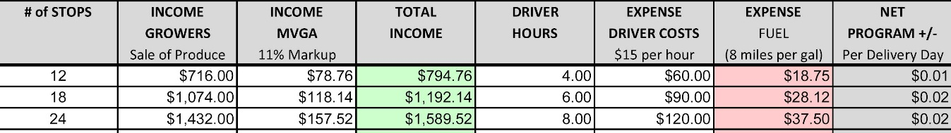
50 miles/$3 per gal./$60 per stop/3 stops per hour
75 miles/$3 per gal./$60 per stop/3 stops per hour
100 miles/$3 per gal./$60 per stop/3 stops per hour

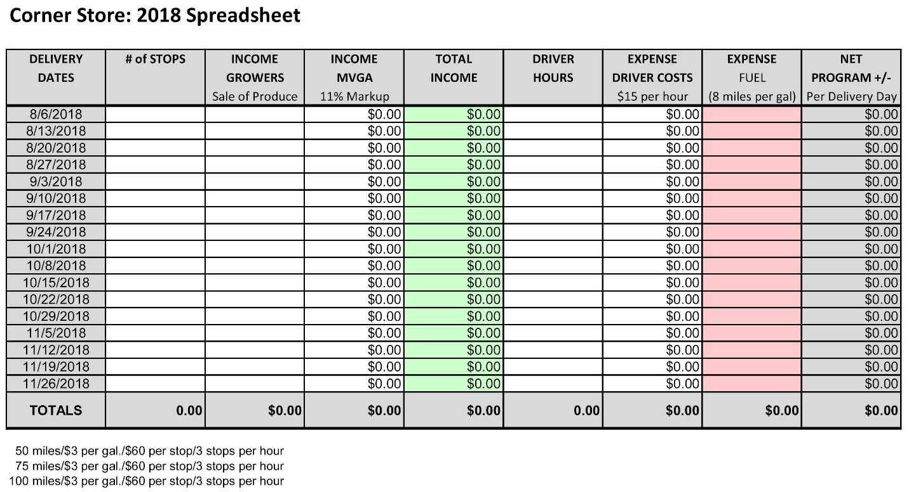

Footnotes

Several valuable sources were referenced throughout the execution of the feasibility study. Notably, The Food Trust for which much of this strategic plan was modeled. Their mission to ensure everyone has access to affordable, nutritious food and information to make healthy decisions is consistent with this initiative. The organization works with neighborhoods, schools, grocers, farmers, and policymakers, to develop a comprehensive approach to improved food access that combines nutrition education and greater availability of affordable, healthy food. http://thefoodtrust.org Our contacts were Alvaro Drake-Cortes, Senior Project Manager for the Healthy Corner store Initiative and Carolyn Huckabay, Marketing Coordinator for the Food Trust.
Information gathered from a webinar on 05-17-18 sponsored by the National Good Food Network http://www.ngfn.org/ featuring a presentation by Lauren Poor who works at Health Care Without Harm https://noharm-uscanada.org/content/us-canada/our-team contained valuable information instrumental in implementing several sustainable strategies.
Locally, The Toledo-Lucas County Health Department http://www.lucascountyhealth.com/community-outreach/creating-healthy-communities/healthy-corner-store-program/ , SNAP-Ed, the YMCA, and area small farmers all contribute to an increased chance of the healthy corner store program sustainability. The collaboration is genuine with the mission of connecting the regions small farmer with urban buyers as priority one!

Modeled after the “Healthy Corner Store Initiative” implemented by The Food Trust located in Philadelphia.
28 stores under the Stop & Go and Stop and Shop brands were not visited intentionally. They are owned by the same person who used to participate in the “Eat Fresh Live Well” program which is still ongoing (19 stores currently). He pulled his block of stores out of the program when the produce stopped being delivered (Lott Industry deemed the deliveries unsustainable). The other issues were the fact that deliveries were only biweekly. He would rejoin if the produce was provided through a managed weekly program.

