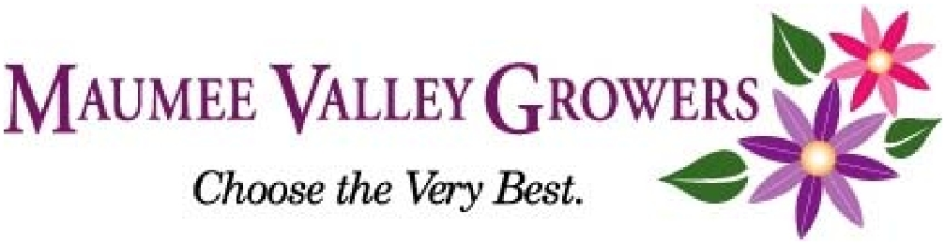
Sponsorship in MVGA

$195
BRONZE LEVEL:
- MVGA Membership and Sponsorship recognition @ MVGA Annual Meeting / Banquet in November.
- Listing on MVGA website.

$325
SILVER LEVEL:
- MVGA Membership and Sponsorship recognition @ MVGA Annual Meeting / Banquet in November.
- Listing on MVGA website
- Your company name & logo printed on all conference and event announcements.

$450
GOLD LEVEL:
- MVGA Membership and Sponsorship Recognition @ MVGA Annual Meeting / Banquet in November.
- Listing on MVGA website.
- Your company name & logo printed on all conference and event announcements.
- Your company name & logo printed on all email correspondences.
Education, Events, and Much More!
The Maumee Valley Growers Association (MVGA) is dedicated to bringing you the
following programs and events that foster education, enhance businesses,
cultivate friendships and encourage networking among our members. By
working together, we can build a brighter future for our members,
our communities and the greenhouse industry as a whole.

Calendar of Events
Join and be a Sponsor of MVGA today!

- Specific dates and locations for each event will be announced and provided as events draw near.
- MVGA bi-monthly board meetings are held the second Thursday of the month at 12:00 pm at the Palmer Energy office on Airport Hwy. All welcome to attend.

January Winter Conference
Education and business programs held at MVGA greenhouse (TBD) in cooperation with industry and trade partners. This year’s theme is “production.”
March Retail Roundtable
Education and business programs for retailers incorporating inspiration and new ideas.
Summer Retail roundtable
Held at local garden center. Retail topics and review of spring sales season. Join MVGA for the planning of next year’s events.
November Annual Meeting
The Lodge at Strawberry Acres, Holland 5:30-10:00 pm. Year-end review and networking.

Contact Name for Mailings
Business Name
Address
E-mail

Return this form and check made out to Maumee Valley Growers Asc. to:
Maumee Valley Growers Asc.
c/o Joe Perlaky
5475 Bayshore Rd.
Oregon, OH 43616
Phone : 419-356-4847
Email: perlaky@bex.net

